Wednesday, September 6, 2023

Demand and Supply (with modeling)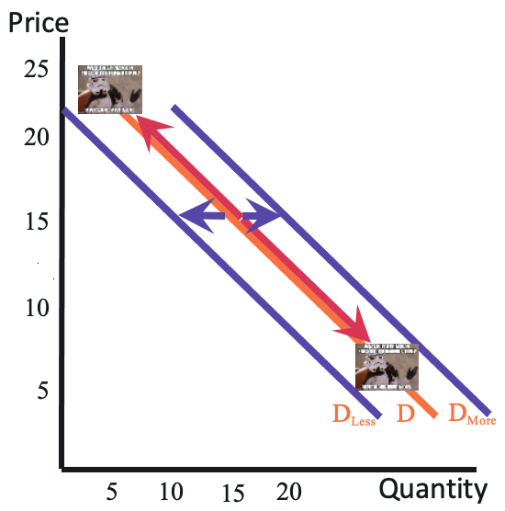

Chapter 3 - ECON 304K

# The Law of Demand

The Law of Demand states that there is an inverse relationship between price and the quantity of a good buyers are willing to purchase. Increases in price raise the the opportunity cost of consuming a good.

Slide or Shift?

A **movement along a demand curve** is a result of a **price change ALONE**. This is known as ***a change in the quantity demanded.***

A **shift in the entire curve** occurs when **something other than the price c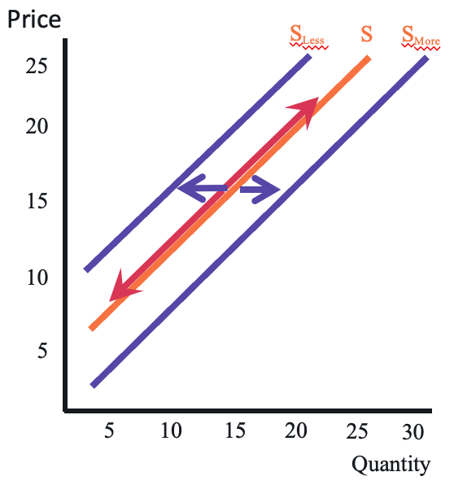hanges**. This is a ***change in demand***.

# The Law of Supply

The Law of Supply is the direct relationship between the price and the amount producers are willing to sell.

Slide or Shift?

A movement along a supply curve is a result of a price change alone. This is known as a change in the quantity supplied.

A shift in the entire curve occurs when something other than the price changes. This is a change in supply

# Market Equilibrium

At a given price, quantity demanded is equal to quantity supplied.

Surplus

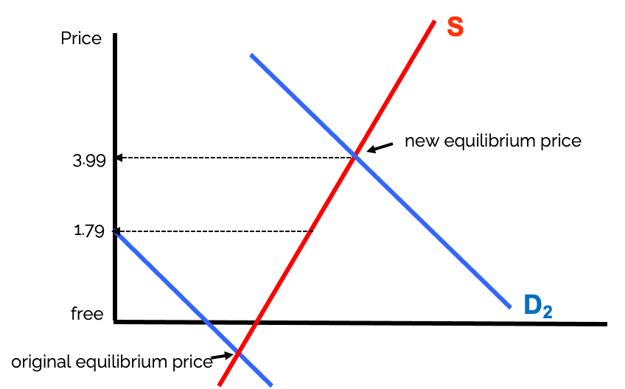

Hudsucker’s Proxy

At a given price, quantity supplied is greater than quantity demanded.

Shortage

At a given price, quantity demanded is greater than quantity demanded

Hudsucker’s Proxy

What price do you charge for a new product that no one has seen before? Mar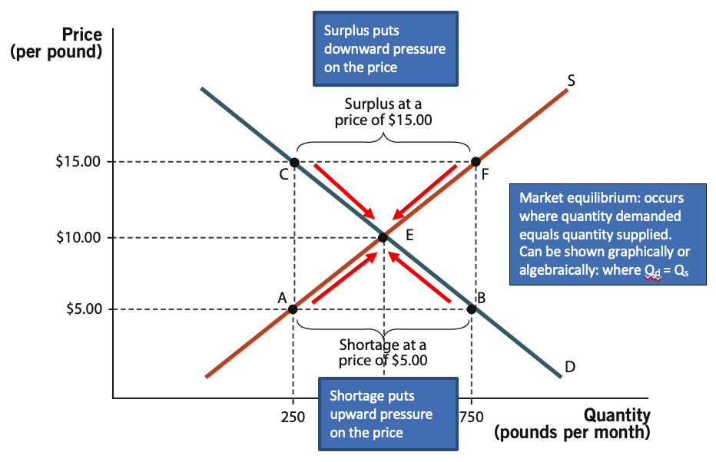kets coordinate prices and eliminate excess supply (surpluses) and excess demand (shortages)